**The impact of covid-19 on pricing and market outcomes in the Indian airline industry**

KANISHKA 232PGE007

|  |  |  |
| --- | --- | --- |
| Keywords |  | Abstract |
| covid-19,  Airline industry,  Indian airline industry,  Operational efficiency  Airline stock returns |  | This paper talks about how the covid-19 outbreak affected the aviation chain in the world. In 2019, numerous countries shutting down their boundaries in response to covid-19 followed by introduction of multiple restrictions. We will talk about how factors like- covid-19 influence Indian airline decision while planning price strategies. Indian airline industry, shedding light on the unparalleled nature of challenges and transformations experienced by key stakeholders. This industry experienced disruptions and the outcome from that affected the circumstances. This paper explores the strategies adopted by Indian airlines, such as cost-cutting measures and government support initiatives, to steer through unpredictable problem. Industry's adaptation to new safety protocols provides insights into the dynamic nature of the sector during the pandemic. emphasizes the critical role of government intervention in providing relief and outlines the uncertainties that continue to shape the recovery trajectory of the Indian airline industry. By examining these aspects, the paper contributes to a comprehensive understanding of the industry's resilience and adaptation in the face of an unprecedented global crisis. |

INTRODUCTION

The coronavirus effected all sectors of economy. The most affected sector is aviation because most transportation was being done by air. It also has impacted the global tourism and more than 50 percent of international travellers used to reach or prefer plane to travel. The study done by ICAO said that the regional breakdown in losses showed a $120 billion loss year-on-year in the Asia-Pacific region, $100 billion in Europe, $88 billion in North America, followed by $26 billion, $22 billion and $14 billion in Latin America and the Caribbean, the Middle East, and Africa, respectively.

Air travel in 2020 was down 60 percent compared to 2019 due to covid outbreak. The covid19 impact had a massive disruption in airline and many challenges faced by company. Many employees got laid off, huge loss incurred. The Indian government also had to extend the deadline for submitting bids for Air India five times during the year.

When the pandemic started spreading across the country, all scheduled international flights and domestic passenger flights were suspended from March 23 and March 25, respectively and there is a huge fluctuation in price of tickets. Scheduled domestic flights were restarted in a limited manner from May 25.

“Indian airlines and airports incurred an estimated loss of Rs 19,564 crore and Rs 5,116 crore, respectively, in 2020-21 due to severe disruption accused by the COVID-19 pandemic”, -wrote Minister of State for Civil Aviation V K Singh. Some ways affected the airline industry are travel restrictions and advisory protocol, flight cancellation and reschedule, financial loss, change in passenger behaviour, government decisions, vaccination impact. India is known as one of the toughest aviation markets, due to expensive taxation (Economic Times, 2012) and highly price-sensitive customers. High fuel prices, market structure, overcapacity and intensive price competition, increased by the recent global recession have resulted in continued losses for majority of airline operators, with one of them, the Kingfisher airlines1 and recent the privatisation that happened in Air India airline.

Similar events can be seen that affected the airline industry in world like the attack of 9/11, grounding of boing 737max, oil price volatility.

DATA

In terms of passenger revenue kilometres, the domestic aviation market was a mere 2.2 per cent shy of reaching pre-pandemic levels, shows a report by an industry body. Revenue Passenger Kilometres (RPK) is a key metric in the aviation industry that measures the demand for air transport. A growing demand for air travel in a country indicates increased business activity. Air travel demand reaching the pre-pandemic level is a strong sign of India's businesses recovering from the pandemic disruption.

Citing the huge loss occurred in Indian airline during pandemic the Civil Aviation Minister Jyotiraditya Scandia in loksabha said ‘This is not limited to India alone this is a global phenomenon, we have monitored fairs, and we have a tariff monitoring unit that looks at 60 routes randomly” as we can see that this not only affected the Indian airlines but also globally. He further said that airlines have made losses of about Rs 55,000 crores to Rs 1,32,000 crore.  
the cost of fuel is also fluctuating because of inadequate supply of oil from countries like Chile.

One study shows that the air turbine fuel is close to 40 percent of the operating cost of the airline and that cost have gone up to rs55,000 per kilo litre to 1,50,000 per kilo litre.

In March, rating agency [ICRA](https://economictimes.indiatimes.com/icra-ltd/stocks/companyid-1311.cms) revised the outlook for India's aviation sector to stable from negative, citing fast-paced recovery in the domestic air passenger traffic. It projected the Indian aviation industry's loss in 2022-23 at Rs 11,000 crore to Rs 13,000 crore and predicted it would reduce to Rs 5,000 to Rs 7,000 crore in the next fiscal. The disruptions resulted in loss of rs2884 incurred indigo and Rs600 crore in spice jet. It estimated that more than 50 million passengers – 55 domestic and 10 million international – world travel data. CAPA (centre for aviation) india project loss 6-6.5 billion in financial year 21, airlines will account for used 4-4.5 billion. As result the government plan to sell AIR INDIA hit.

To escape the pandemic-induced crisis in 2020, all airlines used cost-cutting measures such as layoffs or wage reduction. Go Air put most of its employees on unpaid leave in April. In April, Air India announced a 10% pay decrease for its staff. Indigo start reduces the compensation of its employees and laid them off. Vistara introduced a leave without pay policy for their employee.

Total cargo volumes are likely to drop by 17-20 percent in FY2021," said Anupama Arora, Vice President and Sector Head, ICRA Rating,

Methodology

Airline metrics is essential to assess the performance and health of an airline. this will help in airline management, investors, growth and various aspects of business. Some metrics are- revenue passenger kilometre, available seat kilometre, passenger load factor, revenue available seat kilometre.

These metrics provide a comprehensive view of airline operation and financial performance. But the variable depends of this model is on market segment, overall strategy.

Industry revenues are expected to reach a historic high of $964 billion in 2024. An inventory of 40.1 million flights is expected to be available in 2024, exceeding the 2019 level of 38.9 million and up from the 36.8 million flights expected in 2023 with passenger Revenues taking a huge chunk of the revenues at $717B up 12% from $642 billion in 2023, Revenue passenger kilometres (RPKs) growth is expected to be 9.8% year on year. Passenger yields in 2024 are expected to improve by 1.8% compared to 2023.- acc to IATA 2024 outlooks

The metrics provide the statistical method and supply demand of revenue available seat kilometre and revenue passenger kilometre. Here I will explain how these metrics works and how it helps to portrays the data. ASK (Available seat kilometre) – product of number of seats deployed and distance flown of each flight, indicative of the capacity normally computed at route-sector level

RPK (Revenue passenger kilometre) – product of number of revenue passengers and the distance flown by every flight and their revenue.

The next factor to look into after RPK, ASK and LF, is theAverage Coupon value (ACV) commonly known as average fare. ACV brings about the pricing variable of a passenger journey at a granular-sector level. In other words, the ACV is computed by having the passenger revenue divided by the total passenger numbers.

The profits are measured as component of profit per available seat kilometre to bring the profit/loss of individual airline operation

PASK=RASK-CASK

In conclusion, after studying all the metrics that build up the revenues, I would say a growth in ASK would lead to expected growth in revenues, growth in net sales lead to a higher Load factor and yield. Growth in both Load Factor and Yield lead to a higher RASK. Higher RASK translates to better operating margin

AIRLINE-WISE TRAFFIC AND OPERATING STATISTICS OF SCHEDULED INDIAN AIRLINES ON SCHEDULED DOMESTIC SERVICES DURING 2019-20

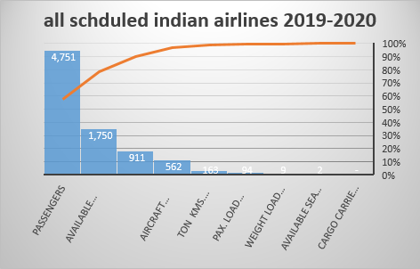

Source- dgca.nic.in

Indian airline industry

The civil aviation industry in India has known as one of the fastest growing industries in the country during the last three years and can be broadly classified into scheduled air transport service which includes domestic and international airlines, non-scheduled air transport service which consists of charter operators and air taxi operators, air cargo service, which includes air transportation of cargo and mail. Domestic traffic contributes around 69% of the total airline traffic in South Asia and India’s airport capacity is expected to handle 1 billion trips annually by 2023. The Indian aviation industry has recovered fully from the covid-19 pandemic shock as indicated by the air traffic movement which stood at 327.28 million in FY23 compared to 188.89 million in FY22.

Indigo is the largest airline company in India with the highest market share. India has become the third-largest domestic aviation market in the world and is expected to o

overtake the UK to become the third-largest air passenger* market by 2024.

Comparing the Indian airline industry with the developing countries in fig 3

Fig2

THE KEY INVESTMENTS

* **According to the data released by the Department for Promotion of Industry and Internal Trade (DPIIT), FDI inflow in India’s air transport sector (including air freight) reached US$ 3.76 billion between April 2000-March 2023. (IBEF REPORT)**
* **The government has allowed 100% FDI under the automatic route in scheduled air transport service, regional air transport service, and domestic scheduled passenger airlines. However, FDI over 49% would require government approval.**
* **In May 2023, Union Civil Aviation Minister Mr. Jyotiraditya Scindia said that there is a plan to invest Rs. 1 lakh crore (US$ 12 billion) in airports in the coming days.**
* **AAI and other Airport Developers have targeted a capital outlay of approximately Rs. 98,000 crores (US$ 12 billion) in the airport sector in the next five years.**
* **The number of PPP airports is likely to increase from five in 2014 to 24 in 2024.**

Passenger growth

Passengers carried by domestic airlines during Jan 2019 were 125.08 lakhs as against 114.65 lakhs during the corresponding period of previous year thereby registering a growth of 9.10% in fig 1

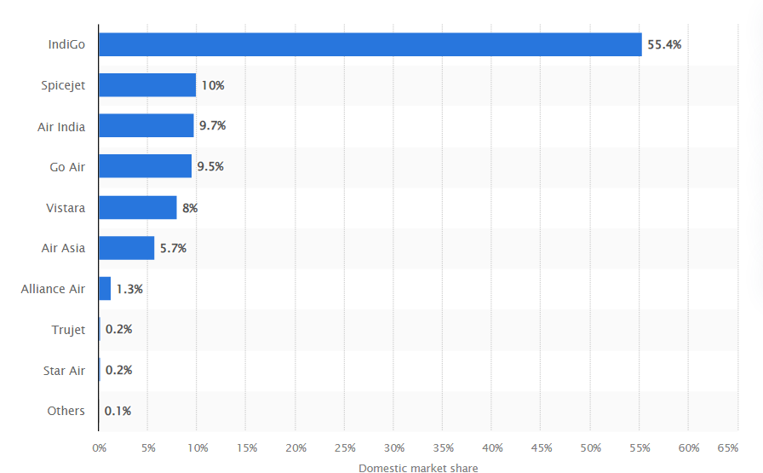domestic market share in indian airline industry in 2019-2020

chart 3

Fig 1 :

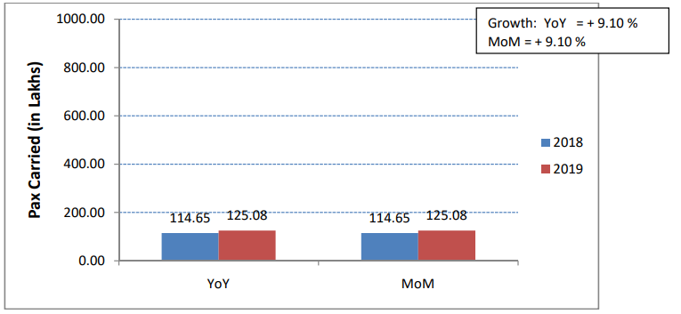

The impact of covid on Indian airline industry can be seen as there is drastic decrease in demand of consumers and in passenger’s demand. We can see by fig 4 that there is a sharp decline in passenger demand as results of protocols, restrictions and outbreak.

Passenger carried over ten years source; https://www.dgca.gov.in/

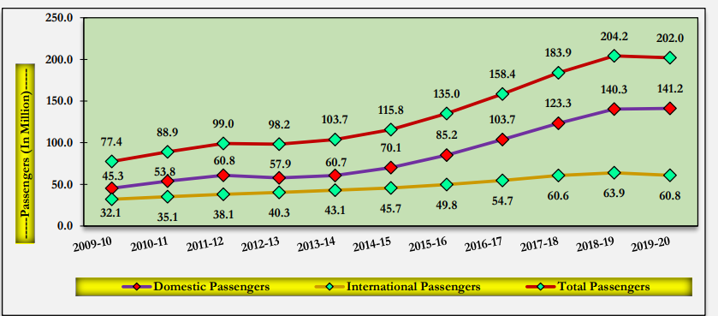

There is a gradually decline in unemployment in this sector as many airlines had to lay off employees or cut their salary because most of the industry experienced financial loss some airline risked the bankruptcy or had to seek for government help.

GOVERNMENT INTIATIVE OR POLICY

Many countries took the initiative to provide the financial support to country and help other countries too. As the outbreak resulted in insufficient amount of supply of vaccination. The Government announced new MRO guidelines on 1st September, 2021 with a view to create a healthy atmosphere in the country for the development of the MRO industry for aircrafts/ helicopters/ drones and their engines and other parts. These guidelines inter-alia provide for the allotment of land at AAI airports through call of open tenders without levy of any royalty or cess of whatsoever nature to MRO operators. Similarly, liberalised Flying Training Organisation (FTO) guidelines have been approved wherein the concept of airport royalty (revenue share payment by FTOs to AAI) has been abolished and land rentals have been significantly rationalised to encourage setting up of FTOs to address the shortage of pilots in the country. The Government has also formulated Helicopter Operation Policy to encourage helicopter operations creating demand and growth.

In order to boost the aviation infrastructure, the Airports Authority of India (AAI) and other airport developers have taken up the development of new and existing airports with a projected capital expenditure of approximately Rest 98,000 crore in the next five years for expansion and modification of existing terminals, new terminals and strengthening of runways, among other activities. Under Greenfield Airport Policy, 2008 of the Government, ‘in principle' approval has been accorded for setting up of 21 Greenfield airports across the country including Navy Mumbai, Shirdi and Sindhudurg in Maharashtra.  So far, ten Greenfield airports have already been operationalized Source-Minister of State in the Ministry of Civil Aviation Gen.

Government released the travel advisory for travellers and maintain a safety protocol to keep safe, collaborate with health authorities. Include- sanitization, social distancing. The govt. also provides aids to employees. international campaigns were run by govt to establish consistenenvy. Tax relief and fee reductions implemented by govt to reduce in aviation related fees to ease financial burden.

Vaccination campaigns were the major chain to protect the people and health workers first and facilitate the recovery of travellers.

Growth of Indian aviation after covid

Aviation industry in India The **domestic passenger traffic registered CAGR of 13.4% during the period FY10 to FY19** while the i**nternational passenger traffic grew at a CAGR of 9.3%** during the same period.

* Aviation industry in India by 2033, airport traffic in India is expected to grow by 5.3 times.
* As per IATA, India is forecasted to gain an additional 359 million passengers by 2037, compared to 2017.

As per the report released by Federation of Indian Chambers of Commerce & Industry (FICCI), Aviation industry in India by FY40, the passenger traffic (to, from and within India) is **expected to grow by 6 times to reach 1.1 billion from the current 187 million in FY18.**

IATA expects air passenger numbers to, from and **within India to increase by 3.3 times over the next 20 years**, to more than**500 million passenger** journeys per year.

This strong growth outlook for air passenger demand will see India overtake Germany, Japan, Spain, and the UK within the next 10 years, to become the world’s third largest air passenger market.

Conclusion

[Union Civil Aviation](https://economictimes.indiatimes.com/topic/union-civil-aviation) Minister Jyotiraditya Scindia recently said, "In the last five years, we have grown from 2013-14 almost 6 crore passengers to almost 14.5 crore passengers. We forecast by 2027 India will have 40 crore passengers per year. That's the kind of phenomenal growth and if that phenomenal growth has to be made possible it can only be made possible by a number of players coming into the sector"

After privatatison of air India won by Tata group in a USD 2.4billlion equity and loan agreement in January results in enhance the productivity of the airline. Jet airways relaunched in September and the new competition to create 100000 new employments.

G P Rao, former General Manager of Air India said, "India is seeing a phenomenal revival post COVID restrictions though the industry started very slow but it picked up the momentum and is in a full swing. If you see the Indian aviation market, it is the fourth largest next to the US, China and the UK".

The Airports Authority of India, the implementing agency, has awarded 948 routes under the Regional Connectivity Scheme - UDAN, from which 405 routes involving 65 airports have been operationalised as of March this year. Source- union budget

Gradually recovery with uncertainties there were signs of a gradual recovery as travel restrictions eased and vaccination campaigns were initiated, uncertainties stopped. The pace of recovery varied, and the industry continued to face challenges, including evolving variants of the virus and changing travel dynamics.

References

[Market Share Of Indian Airline - Search News (bing.com)](https://www.bing.com/news/search?q=Market+Share+Of+Indian+Airline&qpvt=market+share+of+indian+airline&FORM=EWRE)

Agrawal, A., 2021. Sustainability of airlines in India with Covid-19: Challenges ahead and possible way-outs. *Journal of Revenue and Pricing Management*, *20*(4), pp.457-472.

Manteno, Sakkakom, and Suntichai Kotcharin. "The impacts of COVID-19 on the global airline industry: An event study approach." *Journal of air transport management* 89 (2020): 101920.

Kumari V, Tiwari BK, Gupta P, Pandey DK. How the global airline industry behaved to restrictions on air travel to India? An event study analysis. This is an original manuscript of an article published by Taylor & Francis in Economic Research-Ekonomska Istraživanja, on. 2021 May 5;28(05):2022.

Jha, S. S., Arora, A., & Dayal, T. (2021). Is covid-19 decaying the financial health of the aviation industry in india. *Available at SSRN 3894913*.

[The Economic Times: Business News, Personal Finance, Financial News, India Stock Market Investing, Economy News, SENSEX, NIFTY, NSE, BSE Live, IPO News (indiatimes.com)](https://economictimes.indiatimes.com/defaultinterstitial.cms)

[American Airlines Group Stock Price Today | NASDAQ AAL Live Ticker - Investing.com](https://www.investing.com/equities/american-airlines-group)

[Home | Directorate General of Civil Aviation | Government of India (dgca.gov.in)](https://www.dgca.gov.in/digigov-portal/)

<http://www.indexmundi.com/commodities/?commodity=jet-fuel&amp;months=120>

<http://www.breakingtravelnews.com/news/article/goair-ranked-the-best-performing-airline-by-airbus/>